**Finals Reference Sheet – ICT**

**1. Flowchart, Pseudocode, Data Types**

Symbols:

Start

End

Next Step

Decision

Process

Input

Output

5 Features of Pseudocode OCIEI

How many identifiers in python?

Today is Sunday. After 53 days, what day is it?

**2. Loop**

Four Components of a Loop:

Two Types of Loops:

Range functions

sum(range(5,1,-1) =

Prime or Not Prime

write code that checks if integer is prime.

**3. Abstraction**

What is a program?

Use backslash to obtain the following statements:

Mike**’**s book

apple

orange

String Index

H E L L O W O R L D

0 1 2 3 4 5 6 7 8 9 10

… -3 -2 -1

[1:4]

[-3:-5:-1]

[3:-3]

[::-2]

String Commands

astr = “string to copy”

‘1’.join(astr)

“”.join(astr.split())

astr[::-1]

astr[0:14:-1]

astr.find(‘g’)

astr.find(‘x’)

Code to represent characters

ASCII and Unicode. How many bits? How many characters?

ASCII

Obtain the letter stored in unicode position 97.

Obtain the unicode position of the letter ‘a’.

What can these commands be used for?

Strings

max([‘a’, 1, ‘B’, ‘c’])

sum([‘a’, 1, ‘B’, ‘c’])

List Commands

mylist = [1,2,3]

L = [‘a’, ‘b’]

mylist.append(e)

mylist.extent(L)

mylist.pop()

mylist.insert(4,e)

mylist.remove(e)

mylist.sort()

mylist.pop(7)

mylist.reverse()

mylist.append([8,9])

mylist.index(e)

lst = [0, ‘b’]

lst.insert(-1,’a’)

lst.insert(10,’c’)

lst = lst.sort()

Write code to sort a string:

string = ‘xyzabc’

Write the output of Split

“This is a test”.split()

Write code using list comprehension to produce the output:

[

1+1, 1+2, 1+3,

2+1, 2+2, 2+3,

3+1, 3+2, 3+3,

4+1, 4+2, 4+3

]

Write dictionary commands

dict_1 = {xxx:yyy, zzz:fff}

empties dictionary

adds all contents of dict_2

Functions

Difference between argument and parameter?

**4. Decomposition and Recursion**

Write code to reverse a string.

Binary Trees

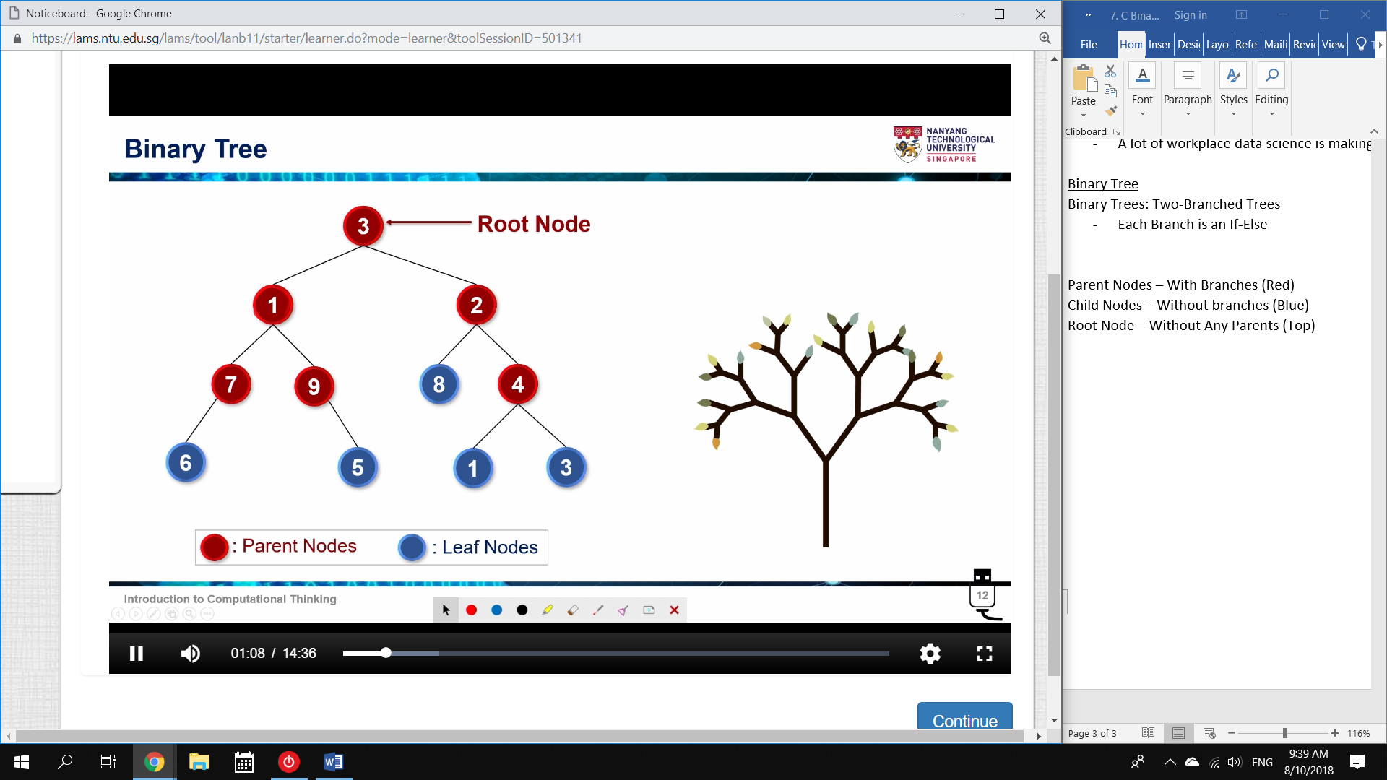

Write code to represent the Tree.

Operations with CBT

Write code to calculate number of Nodes

Write code to obtain max node

Write code to print the Tree

**6. Algorithm Design**

Write code for bubblesort.

Write code for Mergesort

**7. Searching**

Write code for BinarySearch

**8. Time Complexity**

List 4 things that affect computing speed of a program.

Big O Notation

We have learnt 5 different levels of Complexity.

List their:

1. Asymptotic behaviour

2. Big O notation

3. Example of function

**Full List of Functions**

returns true if all the conditions in the arguments are true(acts like AND

function in math

returns true if any of the conditions mentioned in the arguments is true

acts like OR function in math

output will randomly be 1 - 5

returns the index value in which 'abc' occurs

index of character. If not present, **returns -1**

replaces all ‘a’ character with ‘z’ in the string

Ordinal: Number of a object

Character: Letter of a number

List Commands

obtains maximum value in a list.

Append ‘e’ to the back

Append list ‘L’ to the back

remove an index from the list (default is the last, -1)

insert e at index [4]

remove the first e

sort list by ascending order

reverse list

Use ‘str1’ to join the list values together.

Separates values and returns a list.

deletes all the duplicate values present in  
 the list.

sort any iterable data structure with lowercase first.

mylist = [‘a’, 3, 2, 6]

mylist.insert(0,’b’)

mylist.insert(-1,’b’)

mylist.insert(10,’c’)

mylist.remove(‘b’)

mylist.sort()

mylist.remove(‘d’)

mylist.reverse()